Lab Report
Use this template to document your work as you complete your assignment.

Your Information
Your Name: Damien Harmon
Assignment Title: Project 3.2 Supervised and Unsupervised Machine Learning Models

Screenshots
As you complete the procedure, add the screenshots for the required step(s) below. Be sure to include your computer system date and time.
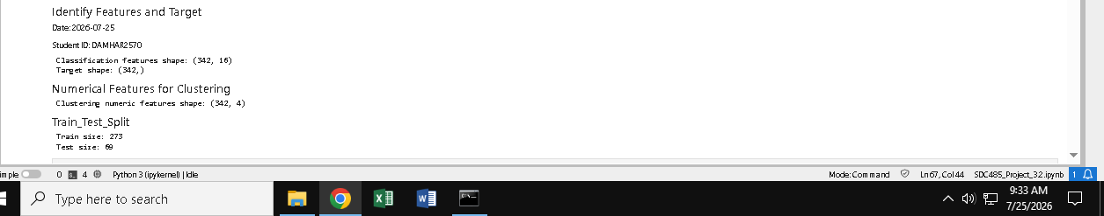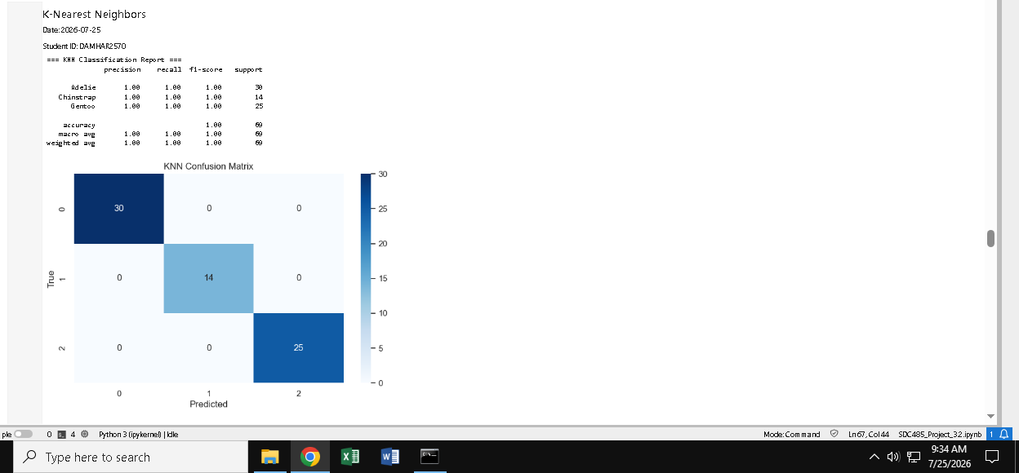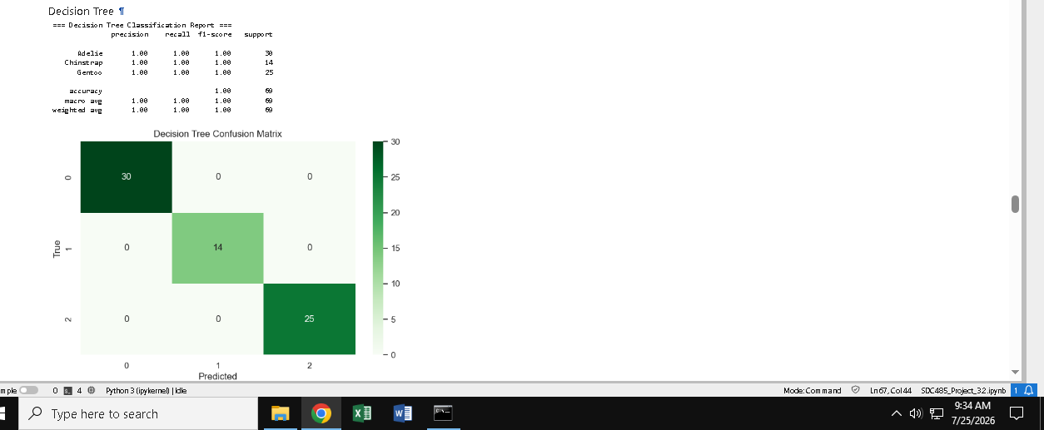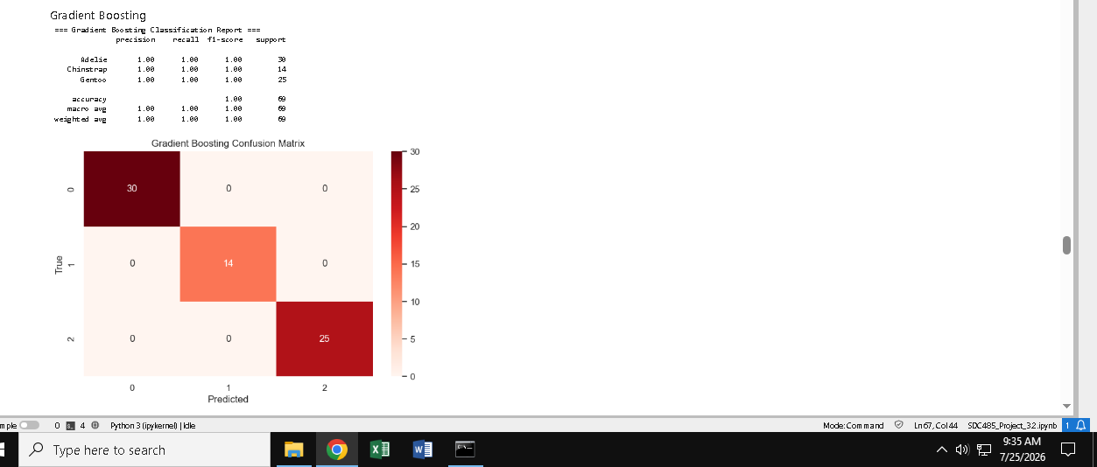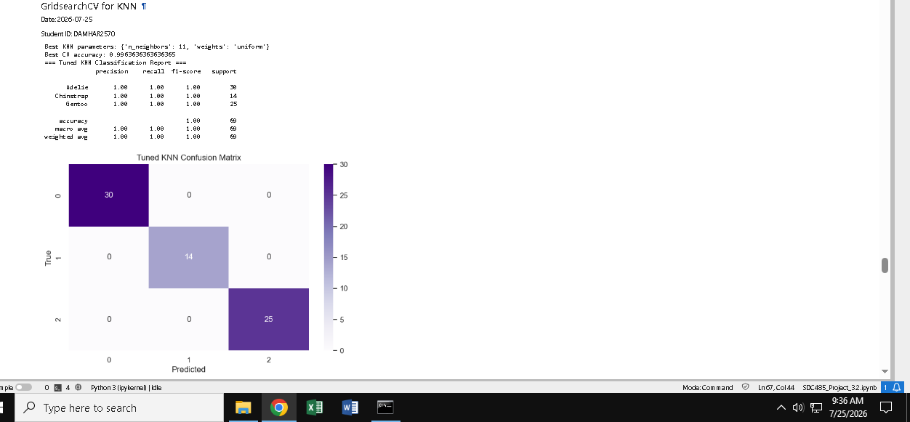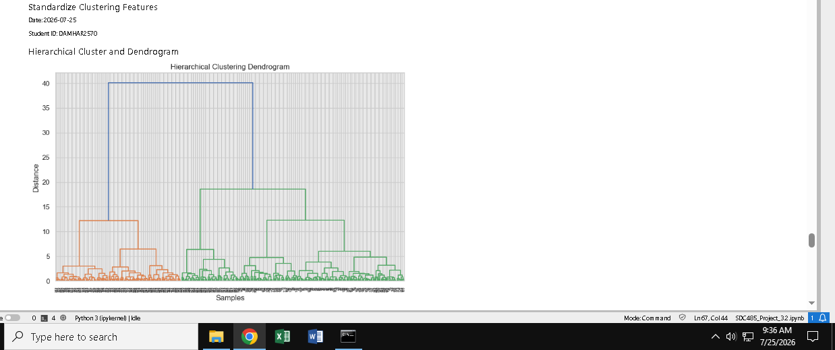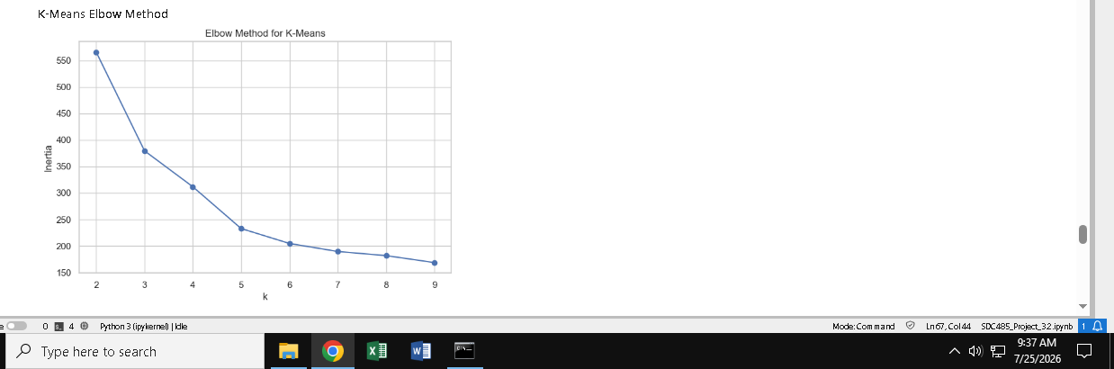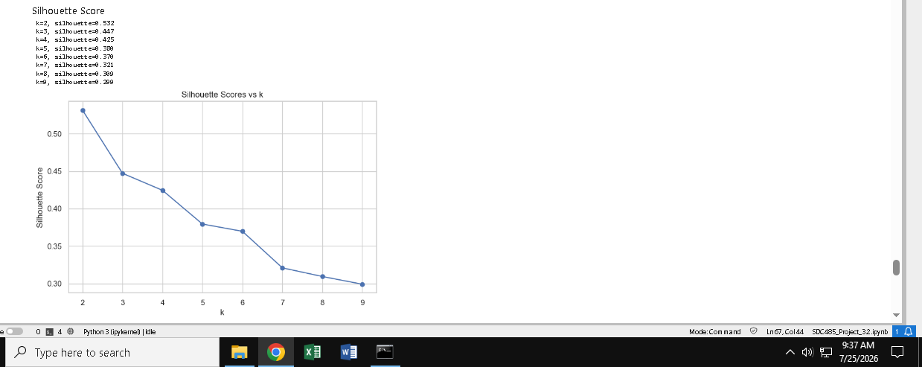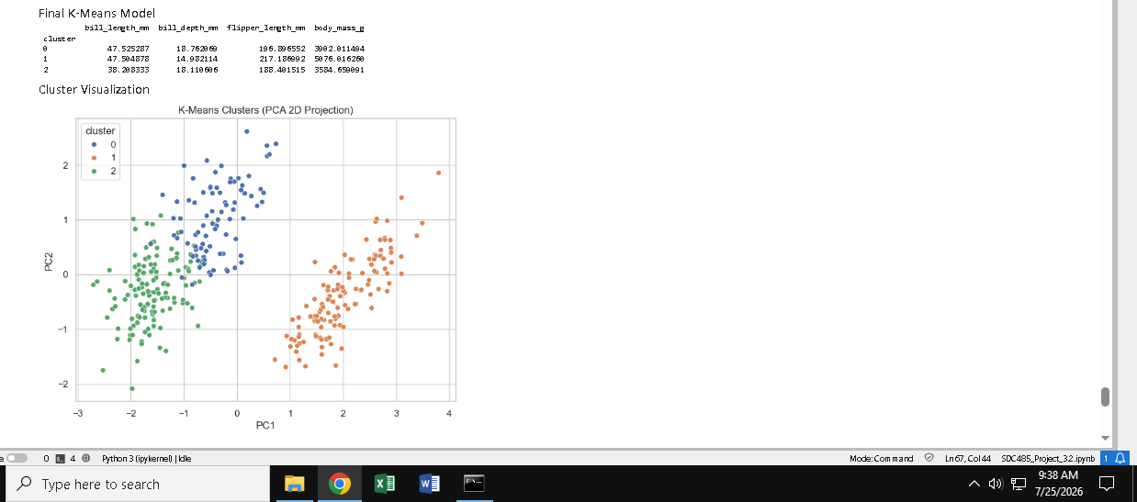

Questions
Answer the required questions in the space below.
Which classification model performed best, and why?
Compare accuracy, precision/recall, and confusion matrices. Did GridSearchCV improve the KNN model?
Compare baseline vs tuned KNN metrics. What does the dendrogram suggest about the number of clusters?
Look for big vertical jumps in linkage distance. What values of k are suggested by the Elbow Method and Silhouette Scores?
Refer to plots and printed silhouette scores. What value of k did you select for the final model, and why?
Justify using elbow + silhouette + interpretability. What patterns distinguish the final clusters?
Use clust_df.groupby("cluster").mean() to describe differences in bill length, depth, flipper length, body mass. What limitations could affect the results?
Mention sample size, species imbalance, measurement noise, and choice of features/standardization.

